The History of Rock and Roll

Playing Music form the 50s, 60s, and 70s, and some 80s

Host: Meagan Paese

Broadcast on 96.3 FM, Knight Radio online radio at



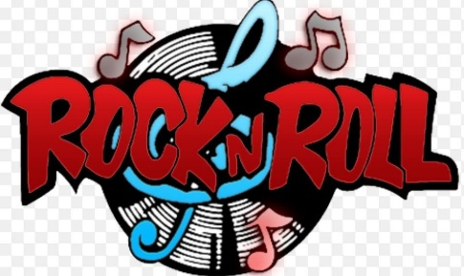 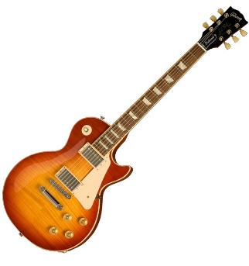

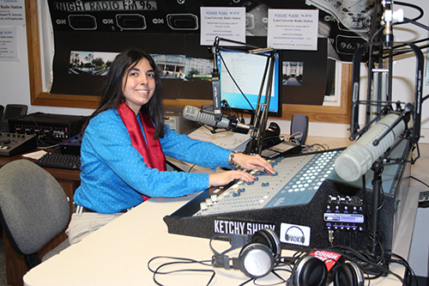

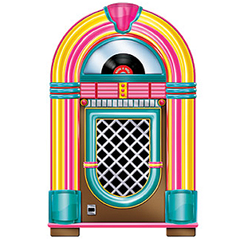 

Tuesday and Thursday at 1:30-4:00

Playing all kinds of rock and roll music by different rock artists from way back then by telling history and keeping memories alive.

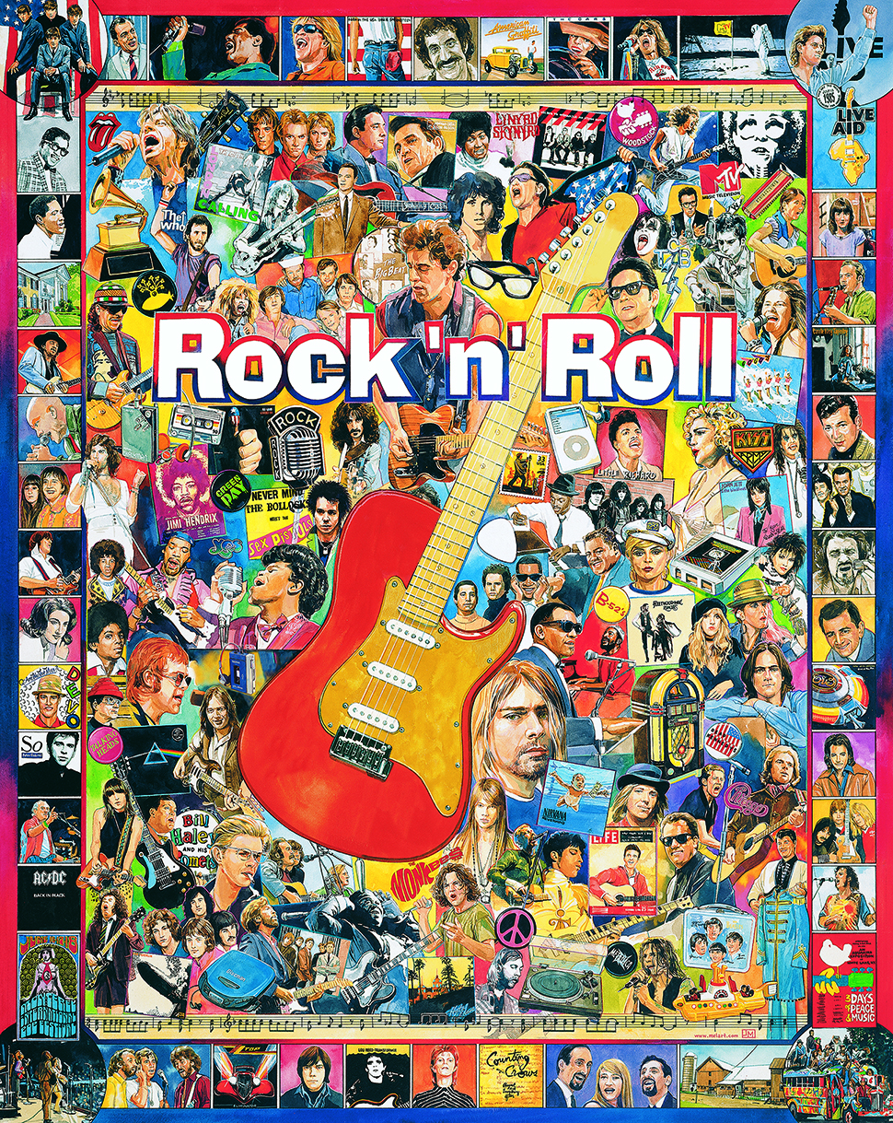

Website: [www.thehistoryofrockandroll.net](http://www.thehistoryofrockandroll.net)